**Task Task 4**

**An interview about my professional background**

**Curso Inglés B2**

Juan Sebastian Castillo Amaya

1116553232

Economía

[900005_86](https://campus120.unad.edu.co/ses05/user/index.php?id=43&group=2454)

[LINA MARIA URREA SIERRA](https://campus120.unad.edu.co/ses05/user/view.php?id=1096887&course=43)

**Universidad Nacional Abierta y a Distancia**

**UNAD**

(28/12/2024)

.

**Task Task 4**

**An interview about my professional background**

**Recording audio:**

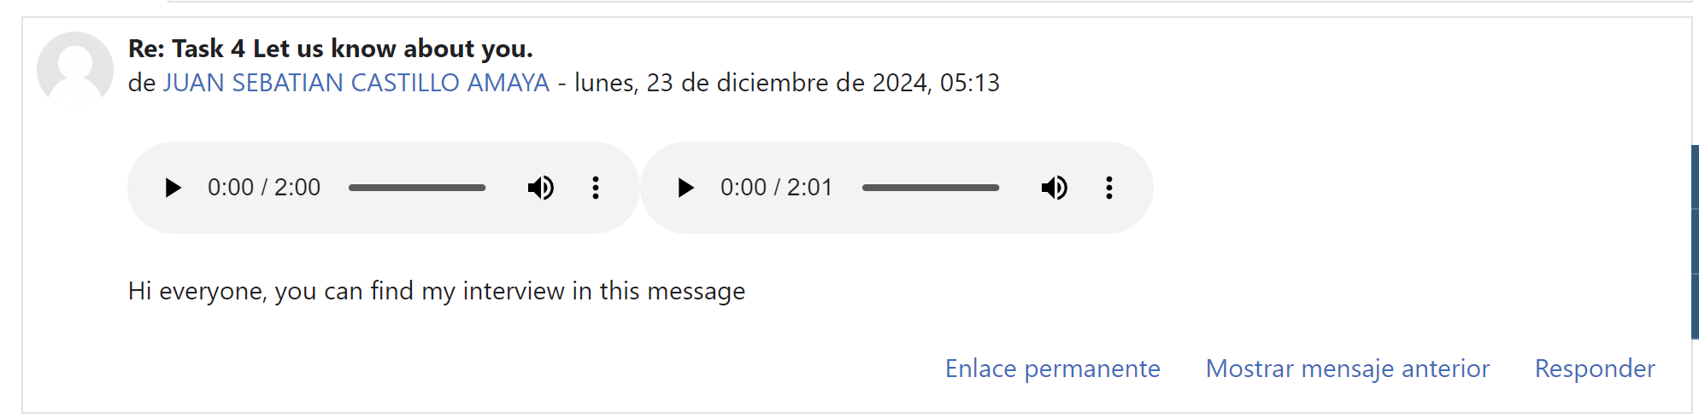

**Interview job with my tutor:**

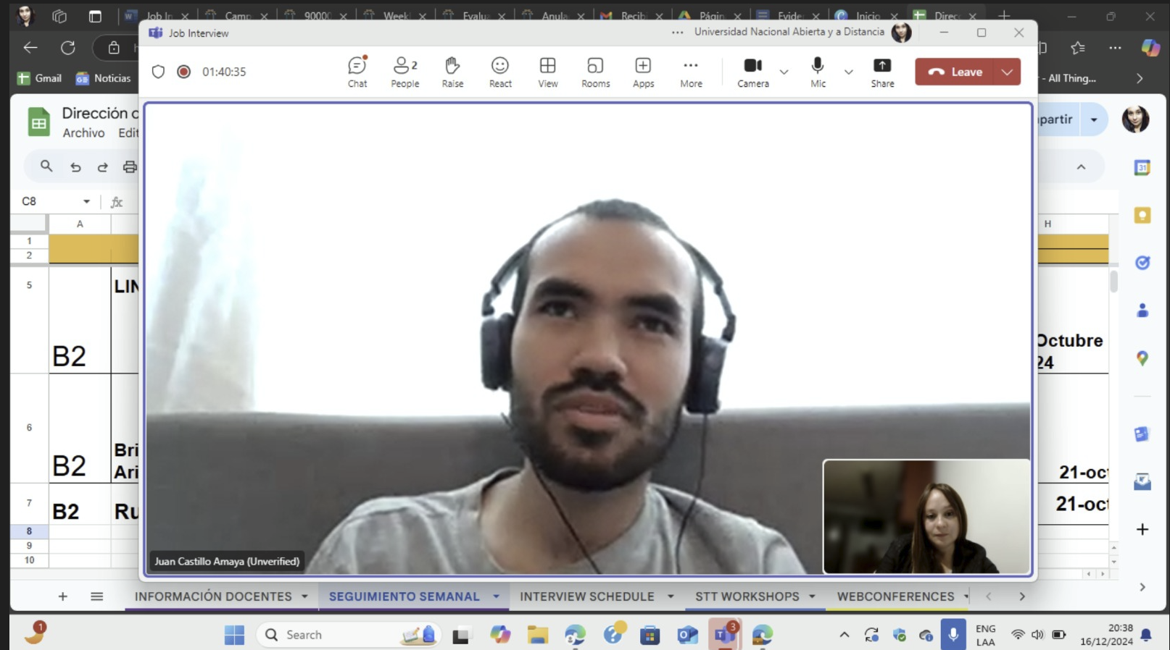

**Comments on my classmate’s recording:**



